**RIPHAH INTERNATIONAL UNIVERSITY, ISLAMABAD**



**Lab 11**

**Bachelors of Computer science – 6th semester**

**Subject:** Artificial Intelligence Lab

**Submitted to:** Ma’am Ayesha

**Submitted by:** Areeba Sadaqat

**Sap Id:** 47633

**Date:** 22nd April, 2025

**Question 01:**

**Naive Bayes Algorithm:**

Implement the naive Bayes algorithm on the dataset shared via the given link.

**Dataset**:<https://tinyurl.com/y2r9vzde>

import pandas as pd

from sklearn.model_selection import train_test_split

from sklearn.preprocessing import LabelEncoder

from sklearn.naive_bayes import GaussianNB

from sklearn.metrics import accuracy_score, classification_report

# Step 1: Load the dataset

df = pd.read_csv("Iris Dataset - Public Livelihood Data.csv")

df.dropna(inplace=True)

# Step 2: Encode all columns (categorical to numeric using LabelEncoder)

label_encoders = {}

for column in df.columns:

le = LabelEncoder()

df[column] = le.fit_transform(df[column])

label_encoders[column] = le # Save encoders if needed later

# Step 3: Split features and target

X = df.drop("Salary", axis=1)

y = df["Salary"]

# Step 4: Train-Test Split

X_train, X_test, y_train, y_test = train_test_split(X, y, test_size=0.2, random_state=42)

# Step 5: Apply Gaussian Naive Bayes

model = GaussianNB()

model.fit(X_train, y_train)

# Step 6: Predictions

y_pred = model.predict(X_test)

# Step 7: Evaluation

accuracy = accuracy_score(y_test, y_pred)

print(f"Model Accuracy: {accuracy}")

print("\nClassification Report:")

print(classification_report(y_test, y_pred))

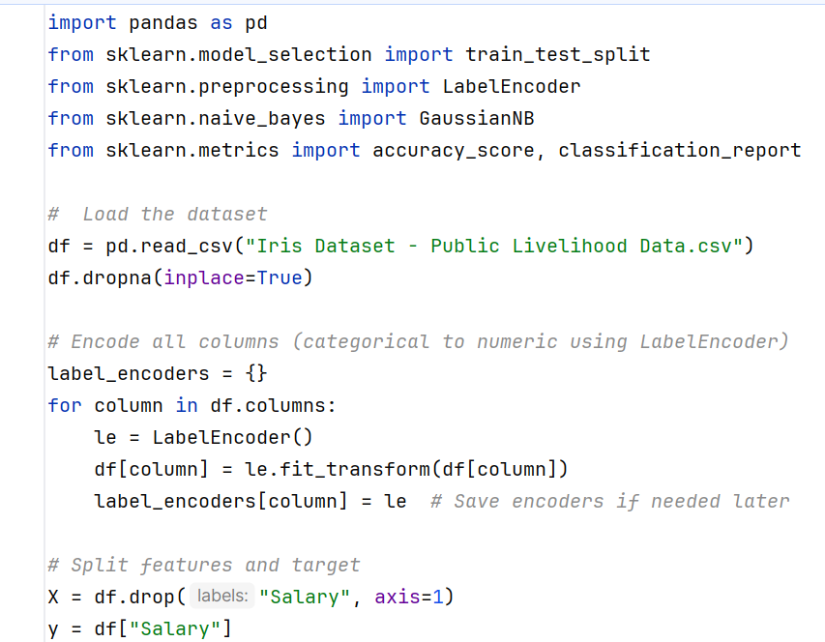

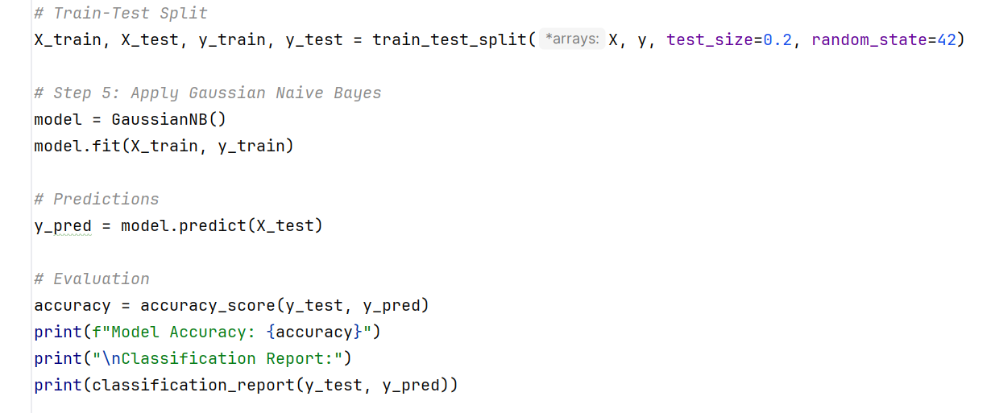

**Output:**

